# Lab 05



**Circuit and System II**

**Submitted by: Maaz Habib**

**Reg. no.: 20pwcse1952**

**Section: C**

**Semester: 3rd**

**Submitted to: Engr Faiz Ullah**

Parallel RLC circuit

Consider a [RLC circuit](https://www.electrical4u.com/rlc-circuit/) in which [resistor,](https://www.electrical4u.com/bleeder-resistor/) [inductor](https://www.electrical4u.com/what-is-inductor-and-inductance-theory-of-inductor/) and [capacitor](https://www.electrical4u.com/what-is-capacitor/) are connected in parallel to each other. This parallel combination is supplied by [voltage](https://www.electrical4u.com/voltage-or-electric-potential-difference/) supply, VS. This **parallel RLC circuit** is exactly opposite to series RLC circuit.

In [series RLC circuit](https://www.electrical4u.com/series-rlc-circuit/), the [current](https://www.electrical4u.com/electric-current-and-theory-of-electricity/) flowing through all the three components i.e the resistor, inductor and capacitor remains the same, but in parallel circuit, the voltage across each element remains the same and the current gets divided in each component depending upon the impedance of each

component. That is why **parallel RLC circuit** is said to have dual relationship with series RLC circuit.

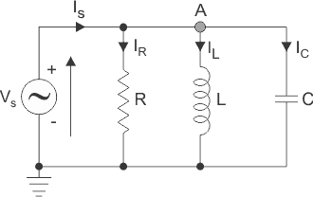

The total current, IS drawn from the supply is equal to the vector sum of the resistive, inductive and capacitive current, not the mathematic sum of the three individual branch currents, as the current flowing in resistor, inductor and capacitor are not in same phase with each other; so they cannot be added arithmetically.

Apply [Kirchhoff’s current law,](https://www.electrical4u.com/kirchhoff-current-law-and-kirchhoff-voltage-law/) which states that the sum of currents entering a junction or node, is equal to the sum of current leaving that node we get,



## Phasor Diagram of Parallel RLC Circuit

Let V is the supply voltage. IS is the total source current.

IR is the current flowing through the resistor. IC is the current flowing through the capacitor. IL is the current flowing through the inductor.

θ is the phase angle difference between supply voltage and current.

For drawing the phasor diagram of parallel RLC circuit, voltage is taken as reference because voltage across each element remains the same and all the other currents i.e IR, IC, IL are drawn relative to this voltage vector. We know that in case of resistor, voltage and current are in same phase; so draw current vector IR in same phase and direction to voltage. In case of capacitor, current leads the voltage by 90o so, draw IC vector leading voltage vector, V by 90o. For inductor, current vector IL lags voltage by 90o so draw IL lagging voltage vector, V by 90o. Now draw the resultant of IR, IC, IL i.e current IS at a phase angle difference of θ with respect to voltage vector, V.

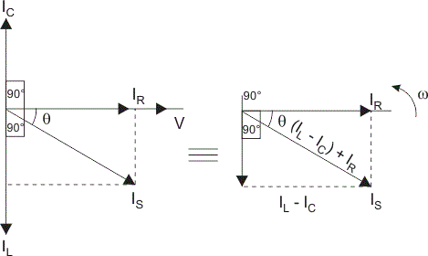

Simplifying the phasor diagram, we get a simplified phasor diagram on right hand side. On this

phasor diagram, we can easily apply Pythagoras’s theorem and we get,



## Impedance of Parallel RLC Circuit

From the phasor diagram of parallel RLC circuit we get,

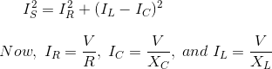

Substituting the value of IR, IC, IL in above equation we get,



On simplifying,



As shown above in the equation of impedance, Z of a parallel RLC circuit each element has reciprocal of impedance (1/Z) i.e [admittance,](https://www.electrical4u.com/admittance/) Y. For solving parallel RLC circuit it is convenient if we find admittance of each branch and the total admittance of the circuit can be found by simply adding

each branch’s admittance.

## Admittance Triangle of Parallel RLC Circuit

In series RLC circuit, impedance is considered, but as stated in introduction on parallel RLC circuit, it is exactly opposite to that of series RLC circuit; so in Parallel RLC circuit, we will consider admittance. The impedance Z has two components; [resistance,](https://www.electrical4u.com/electrical-resistance-and-laws-of-resistance/) R and [reactance](https://www.electrical4u.com/electrical-reactance/), X. Similarly, admittance also has two components such as [conductance,](https://www.electrical4u.com/conductance/) G (reciprocal of resistance, R) and suspceptance, B (reciprocal of reactance, X). So admittance triangle of parallel RLC circuit is completely opposite to that of series

impedance triangle.

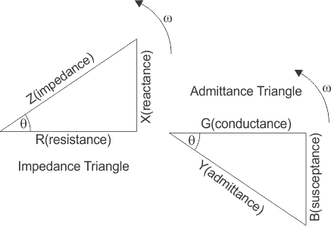

## Resonance in Parallel RLC Circuit

Like series RLC circuit, **parallel RLC circuit** also resonates at particular frequency called resonance frequency i.e. there occurs a frequency at which [inductive reactance](https://www.electrical4u.com/electrical-reactance/) becomes equal to [capacitive](https://www.electrical4u.com/electrical-reactance/) [reactance](https://www.electrical4u.com/electrical-reactance/) but unlike series RLC circuit, in parallel RLC circuit the impedance becomes maximum and the circuit behaves like purely resistive circuit leading to unity [electrical power factor](https://www.electrical4u.com/electrical-power-factor/) of the circuit.

# Equipment

1. AC Function Generator
2. Oscilloscope

# Components

1. 10 nF actual:
2. 10 mH actual:
3. 1 kΩ actual:
4. 10 Ω actual:

# Procedure

1. Using Figure 1 with a 10 V p-p 10 kHz source, R=1kΩ, C=10nF and L=10mH, determine the theoretical capacitive reactance, inductive reactance and circuit impedance, and record the results in Table 1 (the experimental portion of this table will be filled out in step 5). Using the current divider rule, compute the currents in resistor(iR), inductor(iL) and capacitor(iC) and record them in Table 2.
2. Build the circuit of Figure 1 using R=1kΩ, L=10mH and C=10nF. A common method to measure current using the oscilloscope is to place a small current sense resistor in line with the current of interest. If the resistor is much smaller than the surrounding reactance it will have a minimal effect on the current. Because the voltage and current of the resistor are always in phase with each other, the relative phase of the current in question must be the same as that of the sensing resistor’s voltage. Each of the three circuit currents will be measured separately and with respect to the source in order to determine relative phase. Figure 1 To measure the total current, place a 10Ω

resistor between ground and the bottom connection of the parallel components. Set the generator to a 10 V p-p sine wave at 10 kHz.

1. Place probe1 across the generator and probe2 across the sense resistor. Measure the voltage across the sense resistor; calculate the corresponding total current via Ohm’s Law and record in Table 2. Along with the magnitude, be sure to record the time deviation between the sense waveform and the input signal (from which the phase may be determined eventually).
2. Remove the sense resistor and place one 10Ω resistor between the capacitor and ground to serve

as the capacitor current sense. Place a second 10Ω resistor between the resistor and ground to sense the resistor current, and a third 10Ω resistor between the inductor and ground for the

inductor current. Leave probe one at the generator and move probe two across the sense resistor in the resistor branch. Repeat the process to obtain its current, recording the magnitude and phase angle in Table 2. In a similar way move probe2 so that it is first across the capacitor’s sense resistor and then across the inductor sense resistor. Measure and record the appropriate values in Table 2.

1. Compute the deviations between the theoretical and experimental values of Table 2 and record the results in the final columns of Table 2. Based on the experimental values, determine the experimental Z, XL and XC values via Ohm’s Law (XC =VC/IC, XL=VL/IL and XZ=Vin/iin) and record back in Table 1 along with the deviations.
2. Create a phasor plot showing iin, iC, iL and iR. Include both the time domain display and the phasor plot with the technical report.
3. Repeat the experiment for any values of C, L and R.

**Diagram:**

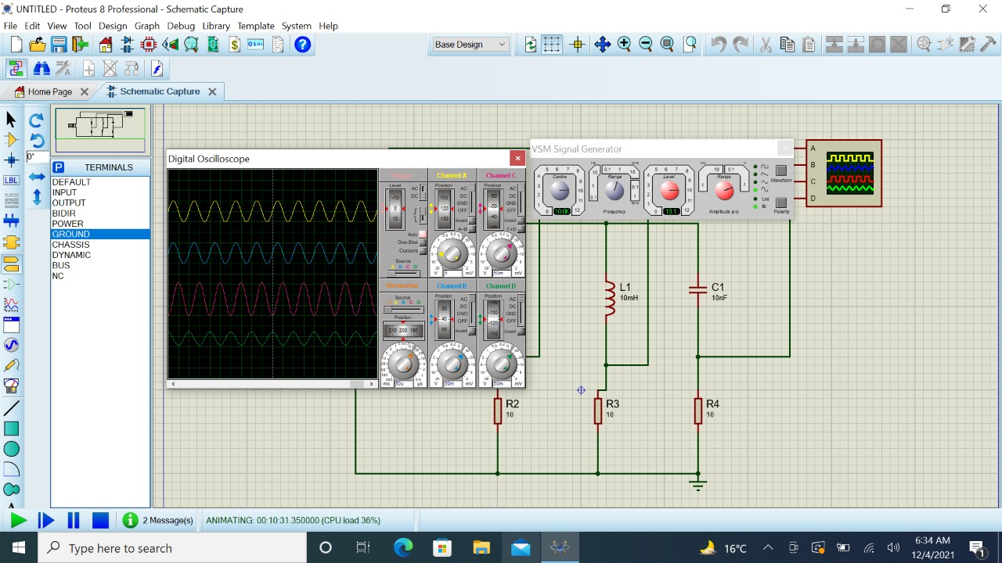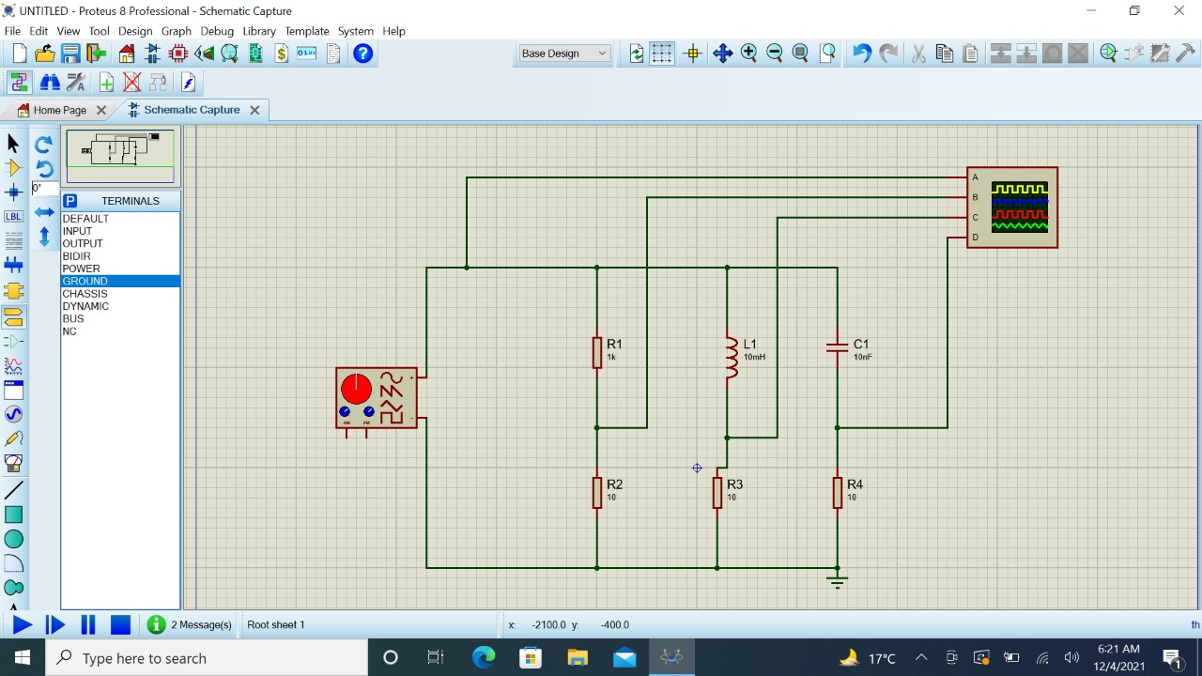

## Table 01

|  |  |  |  |
| --- | --- | --- | --- |
|  | **Theoretical** | **Experimental** | **%Div** |
| Xc | 1592.35Ω | 1666.6 | -4.6% |
| XL | 628 Ω | 666.66 | -6.15% |

|  |  |  |  |
| --- | --- | --- | --- |
| Z | 1389.23 Ω | 1414.17 | -1.79% |
| Ɵ | -43.96 | -44.99 | -2.3% |

|  |  |  |  |
| --- | --- | --- | --- |
|  | **Theoretical** | **Experimental** | **%Div** |
| **IC** | 0.00628A | 0.006A | 3.2% |
| **IL** | 0.015A | 0.015A | 0% |
| **IR** | 0.01A | 0.01A | 0% |
| **IS** | 0.0312A | 0.031A | 0.64% |

**Table 02**

**The end**